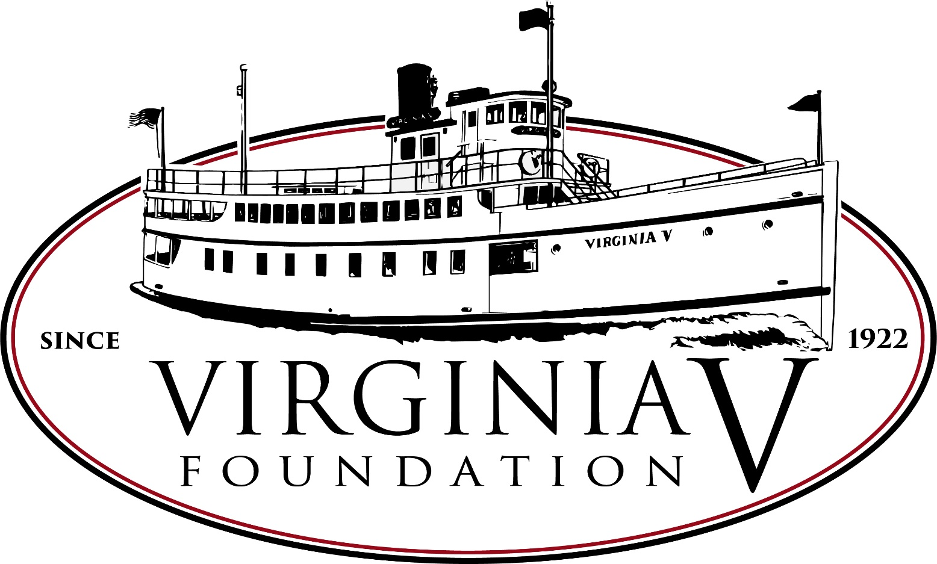

Table of Contents
Table of Contents 2
Introduction 3
History 4
Accessibility 4
Contact 5
Getting to the boat 5
Location 5
AIS 5
Public Transit 5
Parking-Public 6
Parking- ADA 6
Vessel Overview 6
Decks Names and Locations 6
Boat Terminology 8
Boarding the Vessel 8
Bathrooms (Heads) 10
Engine Deck 12
Engine Deck Diagram 14
Main deck 15
Main Deck Diagram 17
Boat Deck 18
Boat Deck Diagram 19
Audio 20
Helpful Links 20

Introduction

History
The VIRGINIA V (five) was built in 1922 for the West Pass Transportation Company to carry freight and passengers from the communities on Vashon Island to Seattle and Tacoma. It is the last of the famous “Mosquito Fleet” ferries that dotted the Puget Sound before cars came on the scene. It is also one of the last wooden, steam powered, propeller driven, passenger vessels in the country.

The Steamer Virginia V (five) Foundation (the Foundation) was formed in 1976 to acquire, preserve, and operate the VIRGINIA V (five).

The Foundation’s mission is to promote the Puget Sound’s maritime heritage through the restoration, preservation, operation, and interpretation of the National Historic Landmark vessel Virginia V (five).

Accessibility
The Foundation strives to create an accessible, welcoming environment for all. However, the SS VIRGINIA V (five) is not compliant with the Americans with Disabilities Act (ADA). To help mitigate that non-compliance, this document is intended as a resource for our community to better understand the unique challenges involved in visiting the SS VIRGINIA V (five).

This document is a living guide, meaning your feedback and comments are much appreciated. If you have any questions or comments about this document, or visiting the VIRGINIA V (five), please do not hesitate to contact us.

Contact
The Steamer Virginia V (five) Foundation
PO Box 9566
Seattle, WA 98109
206-624-9119
info@virginiav.org

Getting to the boat

Location
The VIRGINIA V (five) is primarily docked at the Historic Ships Wharf at Lake Union Park. The approximate address in 860 Terry Ave North Seattle, WA 98109. Google Map Link: https://goo.gl/maps/q2kBAqx8t6G2.

AIS
In addition, the VIRGINIA V (five) is equipped with an Automatic Identification System (AIS). This is a Global Positioning System (GPS) for boats. To find the exact location of the VIRGINIA V (five) during operations, you can log on to a free web-based tool called Vessel Tracker (weblink). Search for VIRGINIA V (five) to find the ships location, direction, and speed.

Public Transit
When docked at Lake Union Park public transit is an option, however, please be aware that the vessel is located at least one quarter mile away from any of the various bus stops around the park. We recommend the google map link above and the mapping services contained within to plan your visit, however any mapping software should work as well.

Transit Links:
South Lake Union Streetcar: https://seattlestreetcar.org/how-to-ride/south-lake-union-line/
Bus Links:
Route 40: https://kingcounty.gov/depts/transportation/metro/schedules-maps/040.aspx
Route 70: https://kingcounty.gov/depts/transportation/metro/schedules-maps/070.aspx
Route 62: https://kingcounty.gov/depts/transportation/metro/schedules-maps/062.aspx
Route C Line: https://kingcounty.gov/depts/transportation/metro/schedules-maps/c-line.aspx

Parking-Public
There are no reserved parking spots for guests of the VIRGINIA V (five). City of Seattle parking is available along Fairview, Valley, or Westlake around Lake Union Park. In addition, there are private lots in Chandlers Cove (on Fairview), in front of Daniels Broiler (on Fairview), and by the AGC Marina (on Westlake). All these locations are a 5-10 minute walk from the VIRGINIA V (five).

Parking- ADA
In Lake Union Park, there are 2 designated accessible parking stalls. To access these, one must approach the Lake Union Park service road from Valley street and approach a gate across the entrance to that road. There, guests can use an access code (##66464) to open the gate, drive to the reserved stall, and walk to the VIRGINIA V (five). These stalls cannot be reserved and are offered on a first come first serve basis.

Google map of the access road and gate location: https://drive.google.com/open?id=1w5lKcUGP10PTxJU8fec59VGVr6xZrAZ0&usp=sharing

Vessel Overview

Decks Names and Locations
The VIRGINIA V (five) has three decks. They are the engine deck, the main deck, and the boat deck.

The engine deck is the lowest deck, and the common boarding deck for guests. The engine deck is where you’ll find the steam engine, the heads (bathrooms), and the galley (kitchen). There are two sets of stairs from this deck to the next deck up.

The main deck is the middle deck. The main cabin is the largest open space on the ship. This is often where seating, food, speakers, and other types of public oriented activities are based. On the foredeck is a set of stairs going to the next deck up.

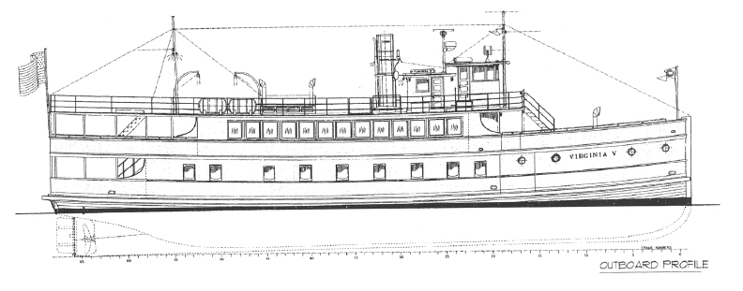
The boat deck is the uppermost deck. It is named for the historical location of the vessel’s lifeboats. This a large open deck, and where you will find the wheelhouse, which is where the Captain of the ship is navigating the vessel.
- Engine Deck
3. Boat Deck
2. Main Deck

Boat Terminology
Port = the left-hand side of the vessel when facing the front of the boat.
Starboard = the right-hand side of the vessel when facing the front of the boat.
Aft or Stern = the rear of the boat
Forward or Bow = the front of the boat
Head = bathroom
Galley = kitchen

Boarding the Vessel
The Steamer Virginia V (five) Foundation will always have crew members present at the boarding hatch of the SS VIRGINIA V (five) during public events and cruises. These crew members are available to assist anyone as needed. Please don’t hesitate to ask for assistance.

When boarding the VIRGINIA V (five) at her normal location at Lake Union Park, the entrance to the ship will vary depending on the level of Lake Union. When the Lake is high in the late Spring and early Summer, the level of the Engine Deck is the same level as the dock, making wheeled devices easy to navigate on and off the vessel.

When the lake level is low, the Foundation will normally put out steps that help visitors down onto the engine deck. These stairs have hand rails on either side.

If steps are not adequate for a guest, the SS VIRGINIA V (five) has a ramp on board the ship that will be deployed if needed or if asked.

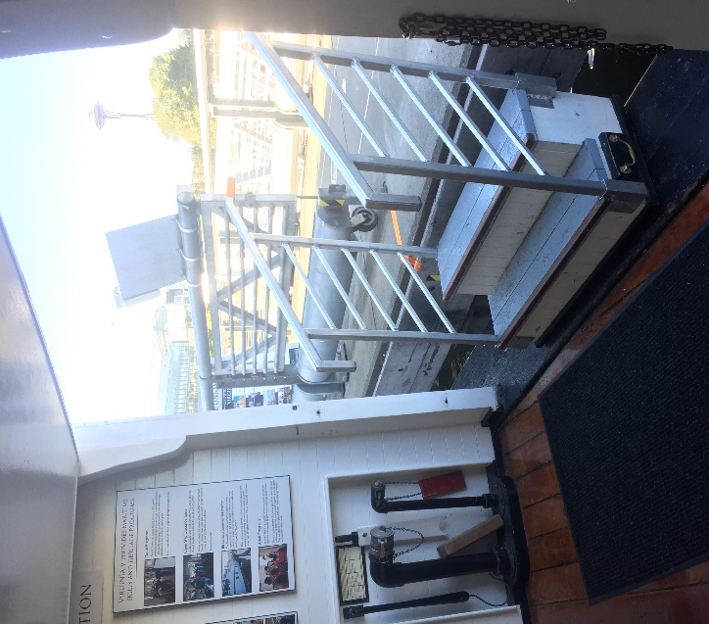
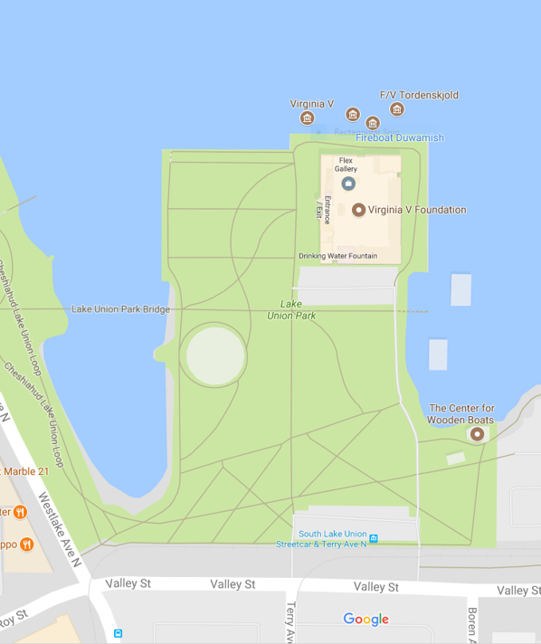
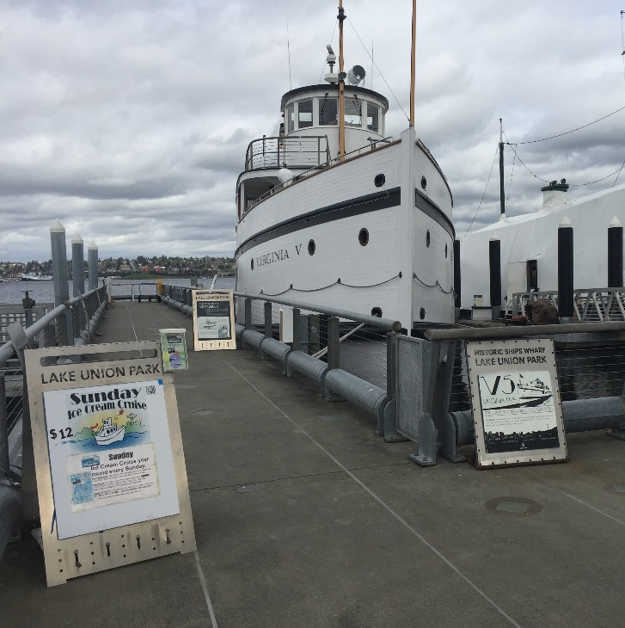

The SS VIRGINIA V at her dock at Lake Union Park. Boarding is on the starboard side of the ship around midships of the vessel.
Map of Lake Union Park from Google maps. The VIRGINIA V is located at the end of Terry Ave at the Historic Ships Wharf. Google Map Link: https://goo.gl/maps/3We86e5bn4B2
Looking from the inside of the boat on the Engine Deck, these are the stairs used to board passengers onto the SS VIRGINIA V.

Bathrooms (Heads)
The Heads on the VIRGINIA V (five) are located on the Engine Deck of the vessel. The Engine Deck is the lowest deck of the vessel. The heads are located forward in front of the steps leading down from the main cabin or to the right after you enter the ship from the boarding hatch.

The men’s head is located on the Port side of the vessel and the women’s head is located on the Starboard side of the vessel. The men’s head has two urinals and one stall, and the women’s head has two stalls.

Neither of the heads meet accessibility standards nor are they ADA compliant.

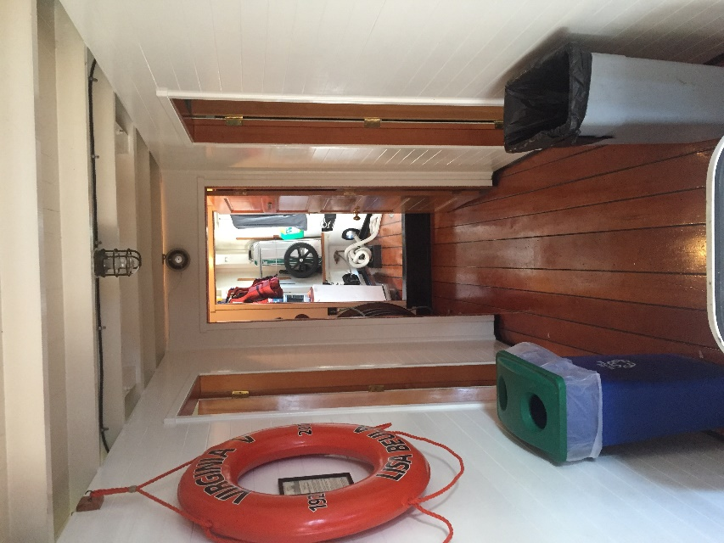
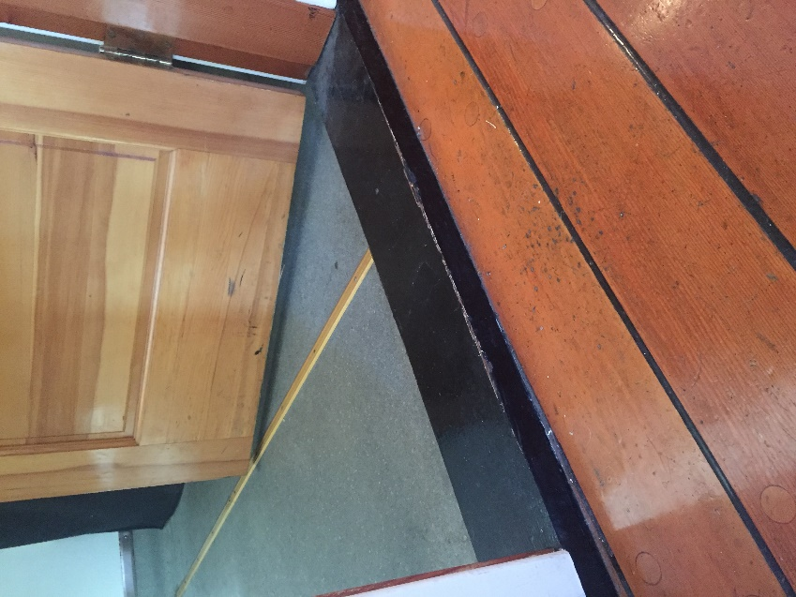
Threshold to men’s and women’s head on the SS VIRGINIA V. Approximate threshold is 1 inch tall.
Entrance area for both heads looking forward. Men’s is on the port (left) women’s is on the starboard (right).
Entrance door to men’s head on the SS VIRGINIA V. The doorway is only 30 inches wide.
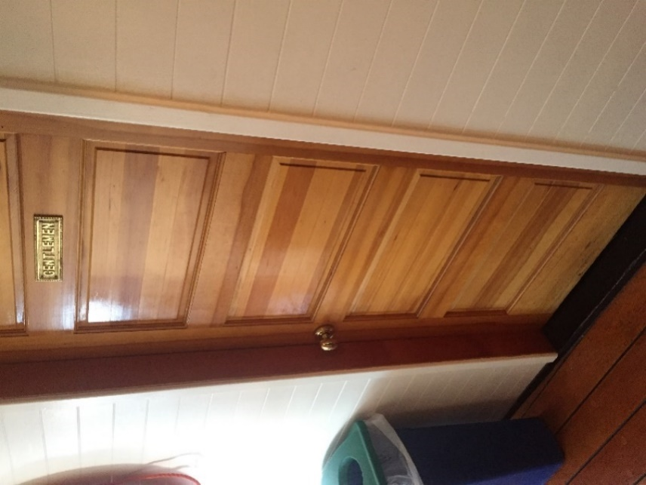

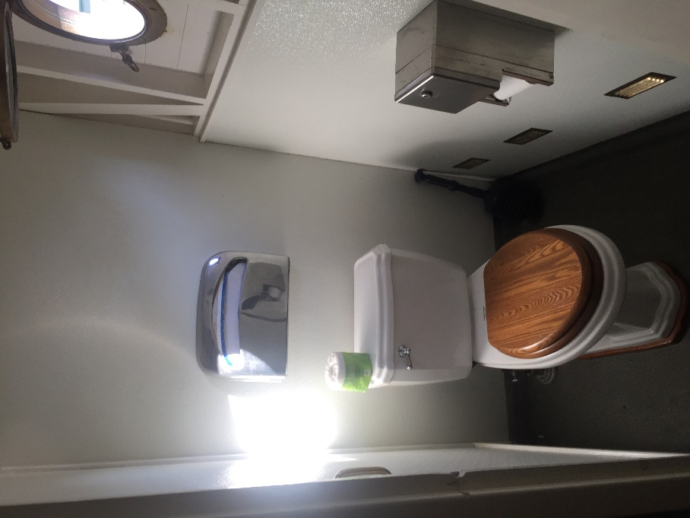
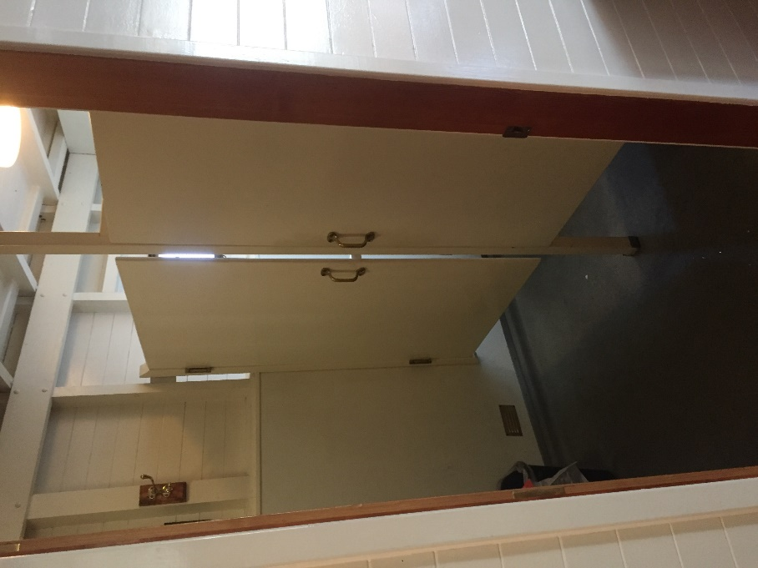
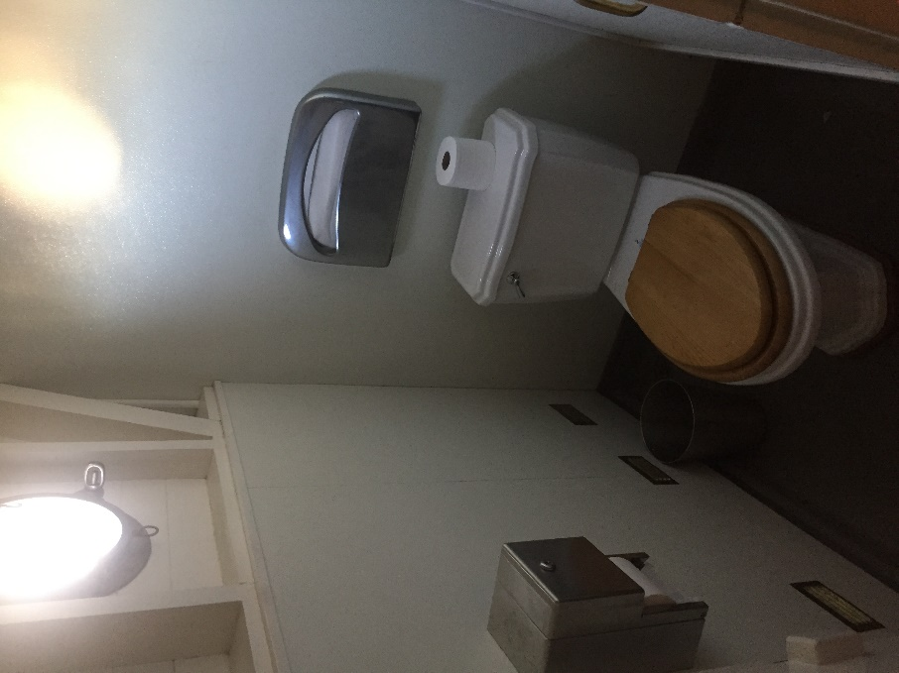

The men’s head bathroom stall on the SS VIRGINIA V. There is only one stall in the men’s head.
The entrance to the women’s head showing the two stall doors on the SS VIRGINIA V. The doorway is 30 inches wide.
One of the two women’s stalls in the women’s head on the SS VIRGINIA V.

Engine Deck
The Engine Deck is the first deck of the vessel. Here you can find the steam engine, the bathrooms, and the galley. There are two sets of stairs on this deck, both leading to the next level up, the Main Deck. In addition, at the rear of the deck there are two exterior doors that lead to an aft deck. These doors have steep thresholds.

At the stern of this deck, there are two doors that lead out to an outdoor space that is covered. These doorways have high thresholds (approximately 4 inches). This aft deck area has a seating area with a cushion and is where you will find stairs leading up to the main deck.

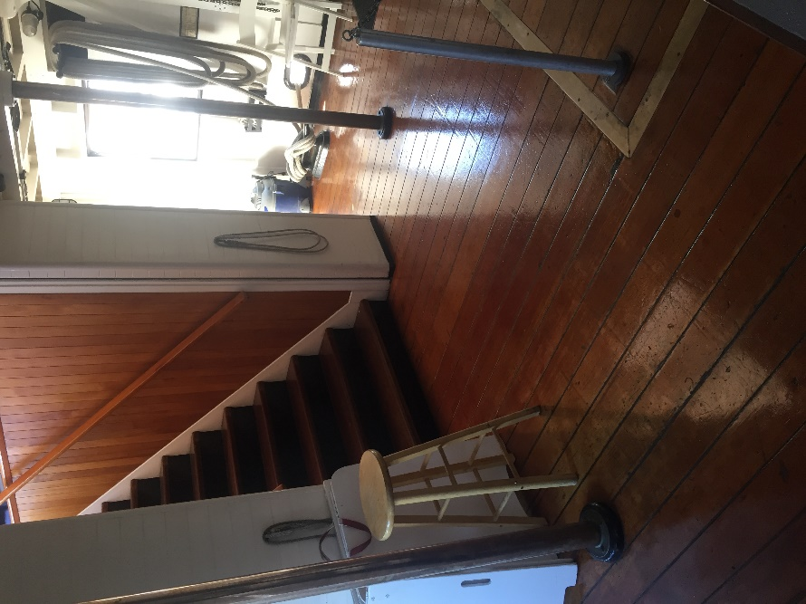
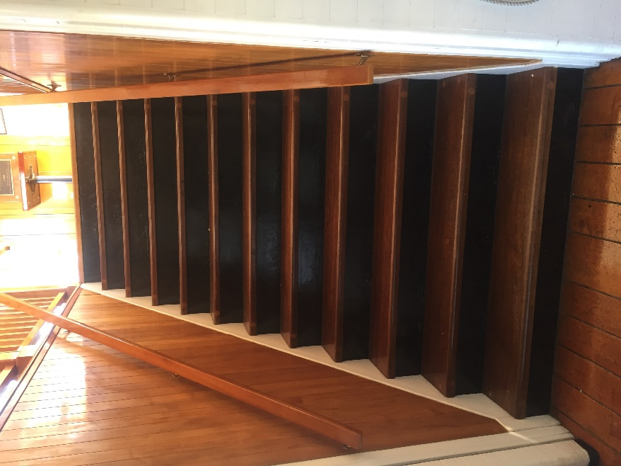
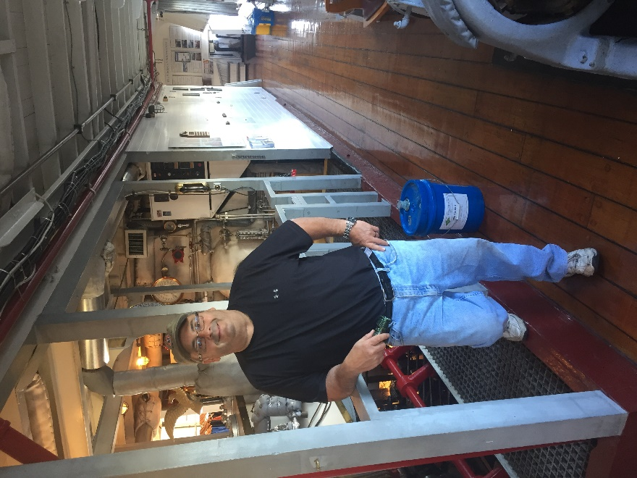
The stairs leading to the main deck from the engine deck of the VIRGINIA V. The stairway have 12 steps and is approximately 5 feet wide.
Main engine of the SS VIRGINIA V on the engine deck. Boarding area visible in the background of the photo.
Boarding area of the engine deck looking towards the starboard of the ship. Steps to main deck visible to the left, entrance to heads on the right (out of sight).

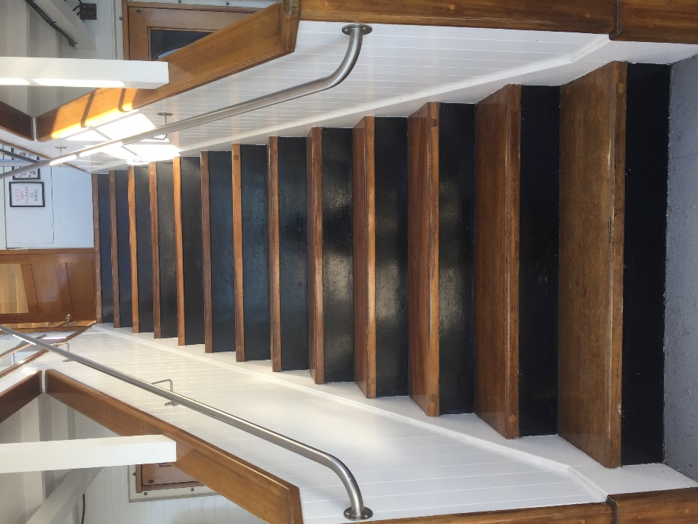
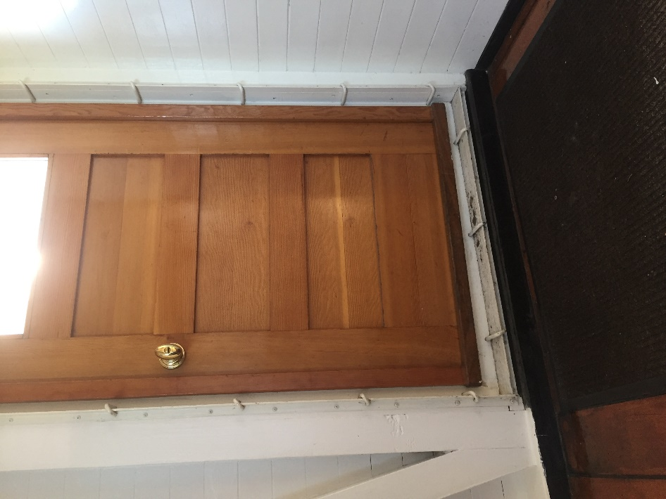
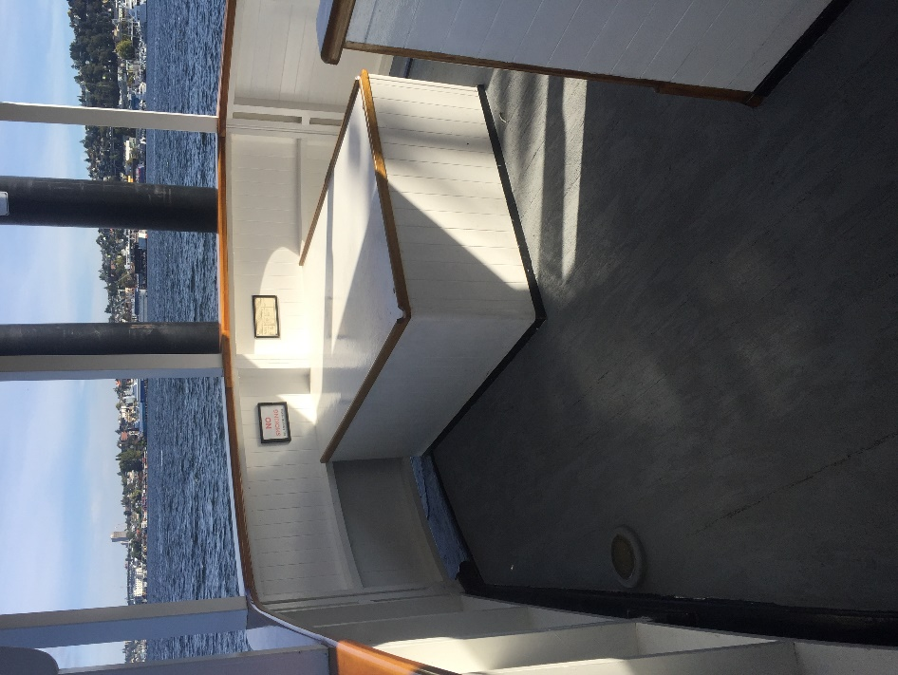
Stairs leading to the main deck from the aft deck of the engine deck have 13 steps. Approximate width of stairwell is 3 feet.
Threshold and door on the engine deck leading out to aft deck area. Approximate threshold height is 3 inches. Identical door on both starboard and port side.
Aft deck area on the VIRGINIA V looking aft from the rear doors. Hatch can be sat on. Steps to the main deck are just to the right in the picture frame.

Engine Deck Diagram
Primary Boarding Hatch
Steps to Main Deck

Steps to Main Deck

Stern
Bow
Port
Heads

Starboard

Main deck
The Main Deck is the second deck of the vessel. The deck is made up of one interior space and two exterior spaces. The main interior space is called the main cabin and is the primary event and program space. This can be used and set up for classes, presentations, dinners, and more. The Foundation has 48 inch round tables and 6 feet banquet tables plus folding chairs that it deploys in this space depending on the needs of the event.

The exterior spaces are the aft deck, which has stairs leading down to the engine deck and is covered. And the foredeck which has stairs leading to the next deck up, the boat deck, and is uncovered.

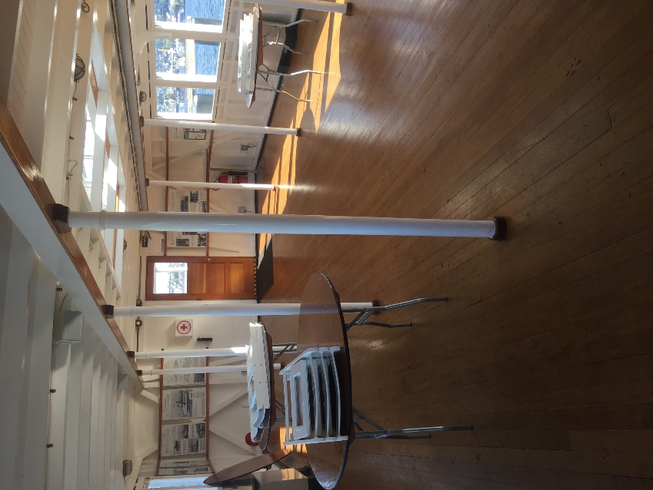
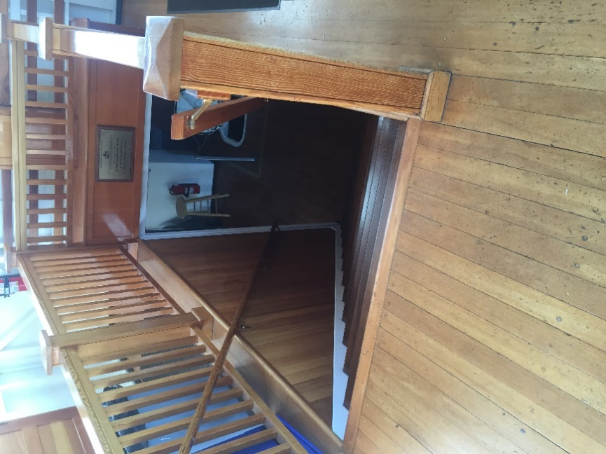
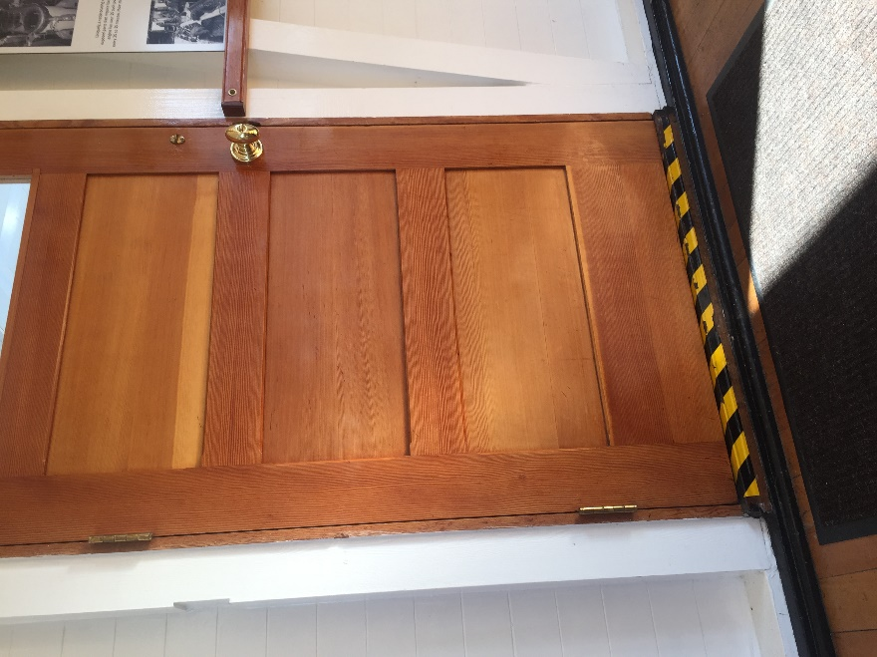

Main deck main cabin area. Tables are 4 feet wide. Chairs are folding and rated up to 250 pounds.
Stairs from the main deck down to the engine deck. View is from the main deck. Stairwell is 5 feet wide.
Door from main cabin to aft deck area on main deck. Approximate threshold = 2 inches. Opens inward.

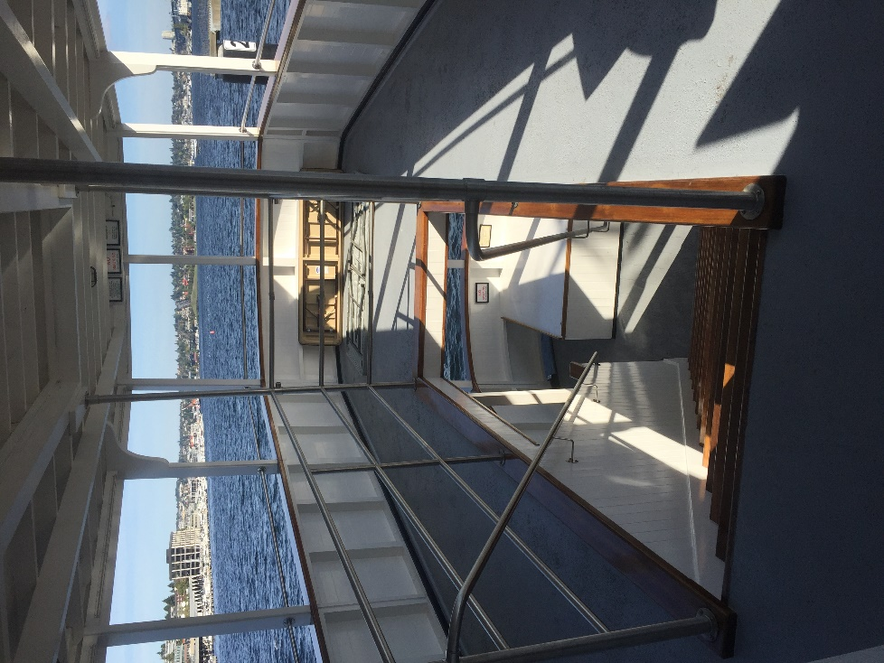
Stairs leading from foredeck on main deck area to the boat deck have 11 steps with open risers. Stairs are approximately 5 feet wide.
Aft deck area on VIRGINIA V’s main deck. View is looking aft. Stairwell is approximately 3 feet wide and descends to engine deck. The open risers on stairways do not meet accessibility and ADA standards.
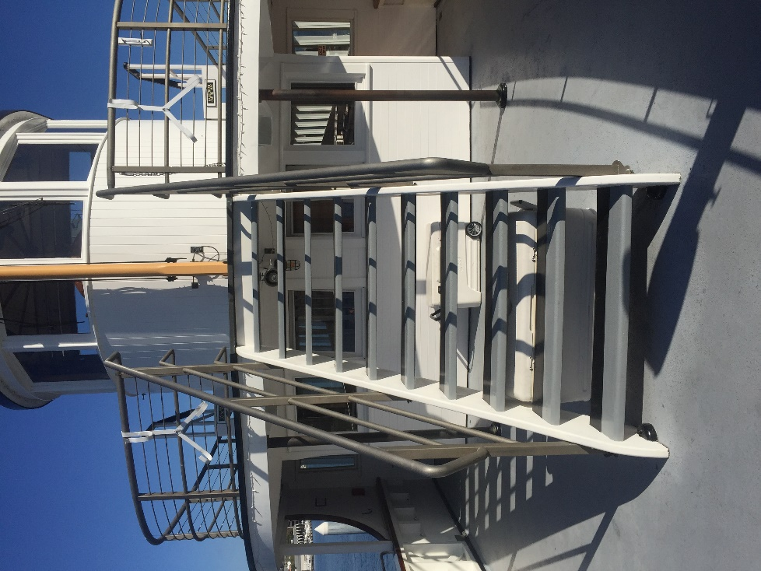
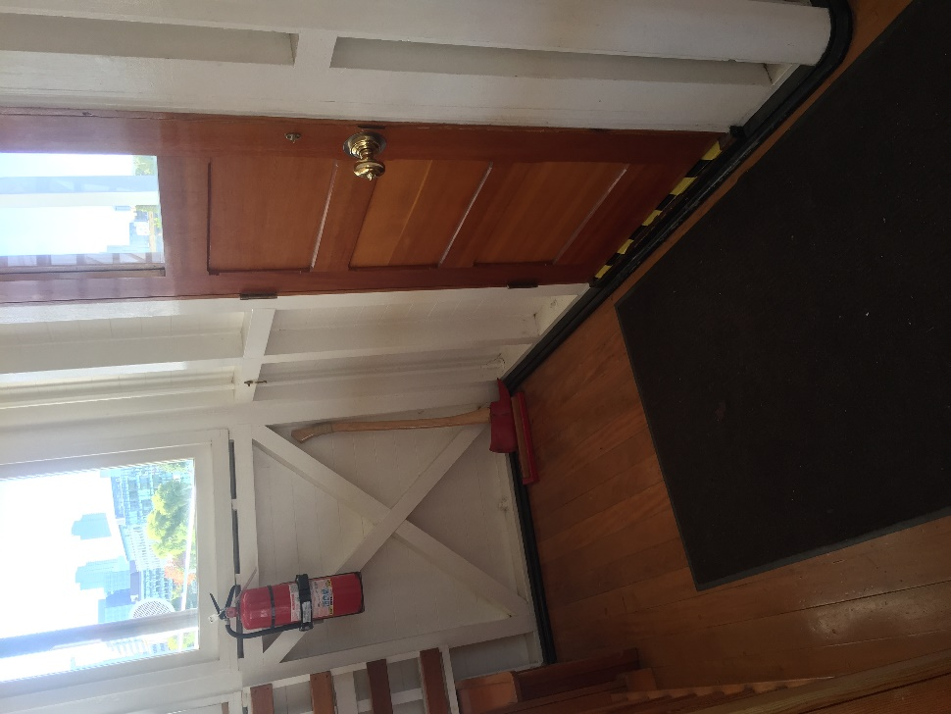
Threshold and door on main deck leading to foredeck.

Main Deck Diagram
Main Cabin

Foredeck
Starboard
Port

Bow
Stern
Steps to Boat Deck
Steps to Engine Deck
Steps to Engine Deck

Boat Deck
The Boat Deck is the third and uppermost deck of the SS VIRGINIA V (five). Here you will find the wheelhouse and a wide-open uncovered deck space. There is passenger limit of 42 on this deck that is enforced by the VIRGINIA V (five) crew. Seating can be found on the clerestory or skylight situated on the middle of this deck.

Entrance to the wheelhouse is by permission of the Captain of the vessel only.

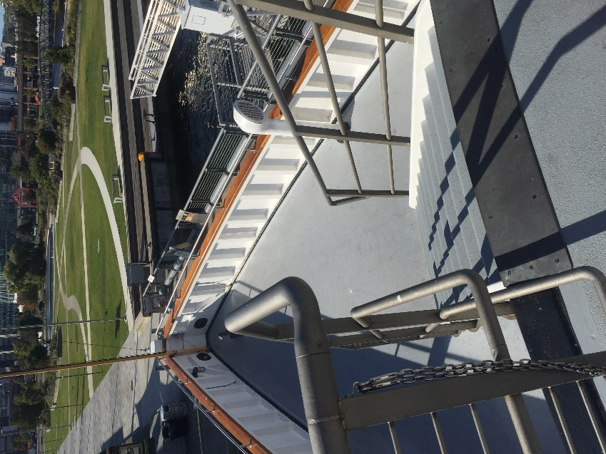
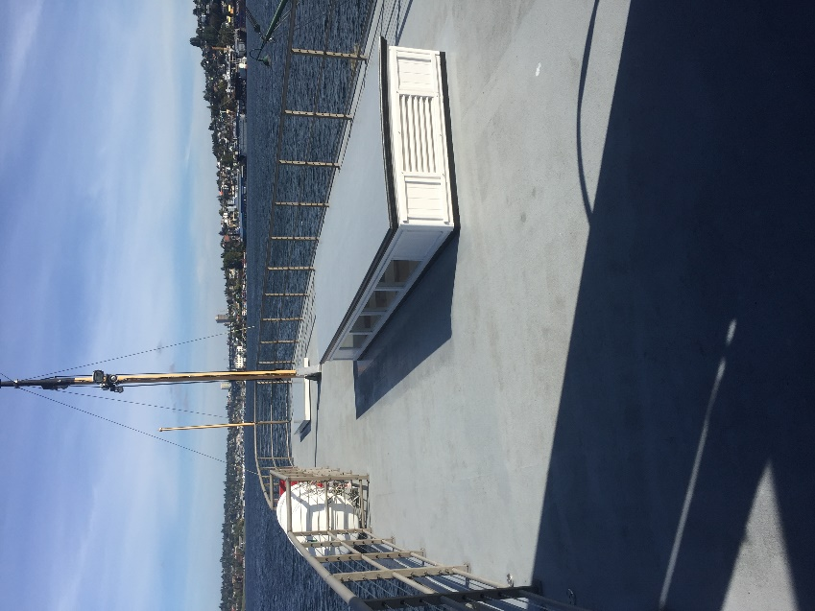
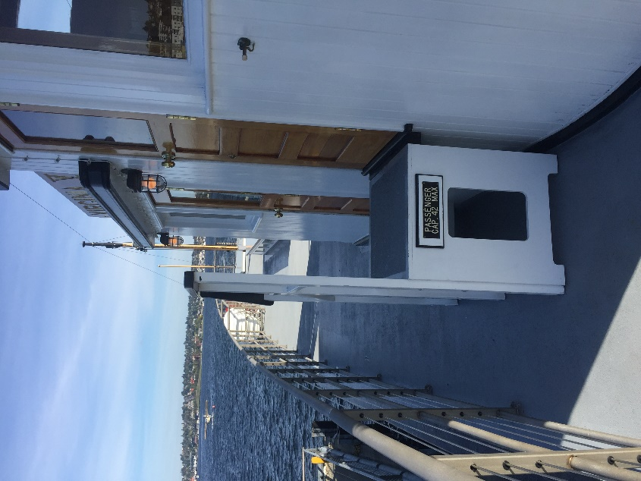
Steps leading down to the foredeck on the main deck from the boat deck. View is looking forward. Stairs are approximately 5 feet wide.
The clerestory on the SS VIRIGNIA V. on the boat deck. Sitting is ok on this structure.
The starboard side of the SS VIRGINIA V wheelhouse looking aft. Approximately 2 feet of clearance between steps and railing. Boat deck has a passenger limit of 42 guests.

Boat Deck Diagram
Steps to the main deck
Bow
Starboard
Port
Stern

The SS VIRGINIA V wheelhouse
The SS VIRGINIA V clerestory

Audio
The SS VIRGINIA V (five) has two public address (P/A) systems on board. One that reaches only the main cabin and foredeck, and one that is ship wide. The main cabin system is used primarily for small presentations for events that take place primarily in the main cabin and the ship wide system is used for narration, emergency announcements, and safety announcements.

The Foundation has access to rent or borrow a system that will accommodate people experiencing hearing loss. If you need accommodation for hearing loss, please don’t hesitate to contact the Foundation to request that equipment.

Helpful Links
- The Steamer Virginia V (five) Foundation email: info@virginiav.org
- Google Map Link to Location at Lake Union Park: https://goo.gl/maps/q2kBAqx8t6G2
- Automatic Identification System tracking: https://www.vesselfinder.com/
- Google map of the access road and gate location: https://drive.google.com/open?id=1w5lKcUGP10PTxJU8fec59VGVr6xZrAZ0&usp=sharing
- The Steamer Virginia V (five) Foundation Facebook page: https://www.facebook.com/ssvirginiav/
- The Steamer Virginia V (five) Foundation Website: www.virginiav.org

